**G H Raisoni College of Engineering & Management, Pune**

**(An Autonomous Institution Affiliated to Savitribai Phule Pune University, Pune)**

**New Gat No. 1200, Domkhel Road, Wagholi, Pune 412207, Maharashtra State, India**

**Email:- ghrcem.pune@raisoni.net Web:-** [**https://ghrcem.raisoni.net/**](https://ghrcem.raisoni.net/)

**Department of Electronics & Telecommunication Engineering**

**A**

**Synopsis of Project**

**On**

**Agricultural Rice Plantation Robot using AI & IOT**

**Submitted By**

1. **Vaibhav Nrupnarayan (Roll.no: 47)**
2. **Harish Bagul (Roll.no: 24)**
3. **Abhiman Bade (Roll.no: 3)**

**Under the Guidance**

**of**

**Dr. Kavita Joshi**

**In the partial fulfillment**

**of**

**Degree of Bachelor in Engineering**

**In**

**Electronics & Telecommunication Engineering**

**G H Raisoni College of Engineering & Management, Pune**

**AY 2024-25**

**Winter Term**



**Project Synopsis**

1. **Introduction:**

Agriculture plays a critical role in the economy, particularly in regions where rice is a staple crop. Traditional rice planting methods are labor-intensive and time-consuming, often leading to inefficiencies and increased costs. To address these challenges, the "Agricultural Rice Plantation Robot using AI & IoT" project aims to develop an innovative solution that automates the rice planting process.

This project leverages Artificial Intelligence (AI) and Internet of Things (IoT) technologies to create a smart, autonomous robotic system capable of performing precise and efficient rice planting. The robot is designed to navigate paddy fields, plant rice seedlings accurately, and monitor environmental conditions in real-time. By integrating AI, the robot can make intelligent decisions to optimize planting patterns and adapt to varying field conditions, ensuring uniform seed distribution and improving crop yield. IoT sensors will provide continuous data on soil moisture, temperature, and other critical parameters, enabling farmers to make informed decisions about crop management.

The introduction of this robotic system aims to revolutionize rice farming by reducing dependency on manual labor, increasing planting accuracy, and enhancing overall productivity. This project represents a significant step towards modernizing agriculture and ensuring food security through technological innovation.

1. **Literature Survey:**

1. Adaptive Policy for Load Frequency Control:

Authors: Y. V. Hote and S. Saxena

This paper discusses the development of an adaptive policy for load frequency control in power systems. The proposed method enhances system stability and reliability by dynamically adjusting control parameters based on real-time data. The techniques and algorithms used in this study can provide insights into developing adaptive control systems for agricultural robots, ensuring optimal performance in varying field conditions.

2. Relative Stability Analysis of Perturbed Cart Inverted Pendulum: An Experimental Approach:

Authors: Y. V. Hote

This research paper presents an experimental approach to the relative stability analysis of a perturbed cart inverted pendulum system. The findings highlight the importance of robust control mechanisms in maintaining system stability under perturbations. The methodologies applied here can be adapted to ensure the stability of the rice plantation robot under various environmental disturbances.

3. Design of a Robust Controller for BLDC Speed Control:

Authors: A. Ahuja and P. Khare

This paper focuses on designing a robust controller for Brushless DC (BLDC) motors used in speed control applications. The control strategies and algorithms discussed are relevant for the precise movement and operation of the rice plantation robot, ensuring accurate planting and efficient navigation through paddy fields.

These references provide a foundation for the development of an agricultural rice plantation robot, highlighting the importance of adaptive control, stability under perturbations, and robust motor control. The integration of AI and IoT in these studies offers valuable insights for enhancing the functionality and efficiency of the proposed robotic system.

1. **Problem Statement:**

Rice planting is a labor-intensive and time-consuming process that requires significant manual effort, leading to increased costs and reduced efficiency in agricultural practices. Traditional methods often result in inconsistent planting, suboptimal crop yields, and an inability to promptly respond to changing environmental conditions.

To address these challenges, there is a need for an innovative solution that can automate the rice plantation process, ensuring precision, efficiency, and adaptability. The development of an Agricultural Rice Plantation Robot using AI and IoT aims to solve these issues by providing an autonomous system capable of performing precise rice planting, real-time monitoring of environmental conditions, and data-driven decision-making to optimize crop management. This solution seeks to enhance productivity, reduce labor dependency, and improve overall agricultural outcomes in rice farming.

1. **Objectives:**

1. Design and Development of the Robotic System:

Objective: To design and construct a fully autonomous robotic system capable of planting rice seedlings. This involves the mechanical design of the robot, selection of appropriate materials, and ensuring the robot can navigate paddy fields. The robot should have the ability to plant seedlings at precise locations with consistent depth and spacing.

2. Integration of AI for Intelligent Planting:

Objective: To implement AI algorithms that enable the robot to make intelligent decisions during the planting process. This includes developing machine learning models for pattern recognition, path planning, and obstacle avoidance. The AI system should adapt to different field conditions and optimize planting patterns for maximum yield.

3. IoT-Based Monitoring and Data Collection:

Objective: To integrate IoT sensors for real-time monitoring of environmental conditions and data collection. This involves using sensors to measure soil moisture, temperature, and other relevant parameters. The data collected will be transmitted to a central database for analysis and decision-making, enabling farmers to monitor field conditions remotely and take timely actions.

4. Development of Control Software:

Objective: To develop robust control software for the operation and management of the robot. This includes writing firmware for the microcontroller, developing user interfaces for remote control, and ensuring seamless communication between the robot and IoT devices. The software should allow for manual override and provide diagnostic information.

5. Testing and Validation in Real Agricultural Settings:

Objective: To test the robot in various real-world agricultural conditions to ensure its reliability and efficiency. Conducting field trials to evaluate the robot’s performance, accuracy of planting, and its adaptability to different terrains and environmental factors. Feedback from these tests will be used to refine and improve the system.

6. Cost Analysis and Feasibility Study:

Objective: To perform a cost analysis and feasibility study to assess the economic viability of the robotic system. This includes estimating the overall cost of the robot, including materials, development, and maintenance. The study will compare the costs and benefits of using the robot versus traditional planting methods, focusing on long-term savings and increased productivity.

By achieving these objectives, the project aims to create a practical, efficient, and scalable solution for rice planting, leveraging the power of AI and IoT to transform agricultural practices and improve productivity.

1. **Scope of the Project:**

The scope of this project can be defined from two perspectives:

Functionality:

* The robot will focus on automating rice planting tasks, including:
  + Seeding: Picking up and precisely placing rice seeds at the desired depth and spacing.
  + Potentially, soil preparation tasks like tilling or creating furrows (depending on project complexity).
* AI will be limited to planting-related decisions based on real-time data:
  + Seedling selection (if applicable)
  + Planting depth adjustment based on soil moisture
  + Seeding density based on pre-programmed parameters or sensor data

Technical Complexity:

* The robot's design will likely involve:
  + A mobile platform for navigating paddy fields (e.g., tracked or wheeled)
  + A manipulation system for handling seeds (e.g., gripper or dispenser)
  + IoT sensors for data collection (e.g., soil moisture, temperature)
* AI algorithms will be designed for:
  + Image recognition (optional, for seedling selection)
  + Sensor data analysis for soil conditions
  + Decision-making on planting parameters

Important Considerations:

* The initial scope might not encompass tasks like weed control, fertilization, or harvesting due to their added complexity.
* The focus will be on developing a functional prototype demonstrating the core functionalities.
* Depending on resources and project goals, the scope can be expanded to include additional features or functionalities in the future.

1. **Block Diagram & Description:**

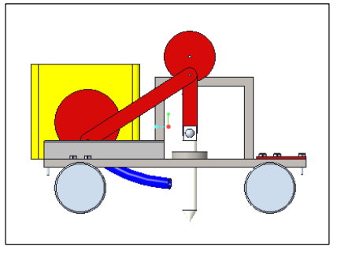

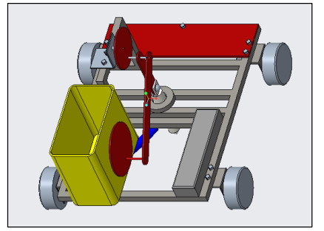

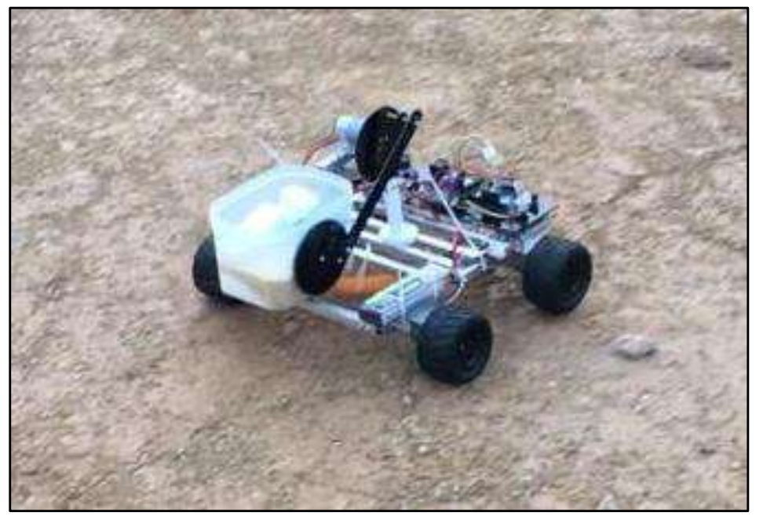

1. **Hardware & Software used:**

The agricultural robot prototype consists of four geared DC motors–each with a voltage and current rating of 5 V and 0.2 A, respectively–driving each wheel to enable movement of the robot base. For this application, DC motors were selected due to their high torque characteristics, good reliability, and low maintenance requirements. The high torque and precise speed regulation offered by the DC motors ensure that the robot can overcome loose soil or muddy surfaces as well as rough terrains in the agriculture fields without issue.

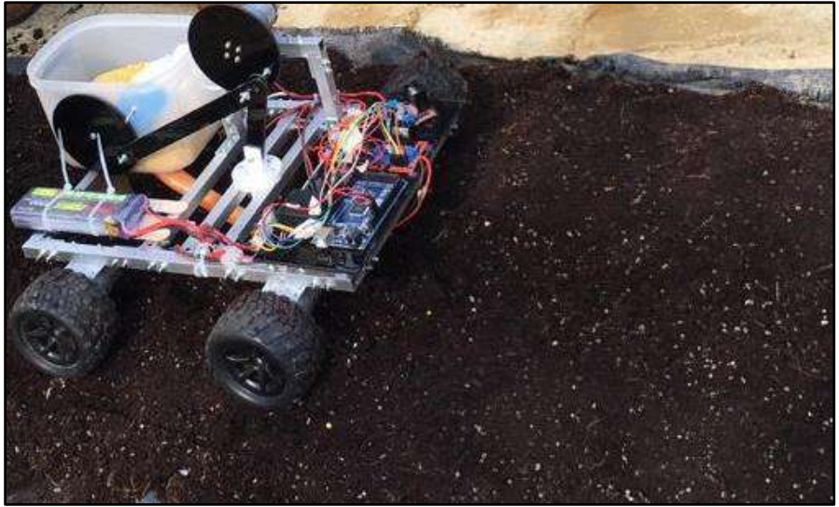

The DC motors are driven by two low-cost L298N motor drivers. The motor drivers act as a current amplifier by receiving a low-current control signal from a microcontroller and converting it into a higher-current signal which can drive a motor. The L298N motor driver is powerful enough to drive motors of up to 2 A per channel with a voltage rating of 5-35 V, which is adequate for the DC motors used in the prototype system. The L298N motor driver allows speed and direction control of two DC motors at the same time. The microcontroller transmits linear speed and steering instructions using digital signals to the motor driver which, in turn, controls the speed and direction of rotation of the DC motors. The microcontroller used for the prototype system is an Arduino Mega. The Arduino Mega is a low-cost and widely available microcontroller with an adequate processing power for this application and can be programmed easily via the Arduino Integrated Development Environment (IDE). Next, a controller is required to govern the movement of the agricultural robot prototype. For this application, a remote-control system was utilised. Remote control is meant to control one or more machines from a distance. In particular, a remote-controlled robot is defined as a robot that is controlled by means that do not limit its movement to external media, such as wiring between the controller and the robot. A wireless PlayStation 2 controller was used to control the agricultural robot prototype as the existing library in the Arduino IDE makes it quick and simple to program compared to other wireless systems such as Bluetooth controllers. Additionally, a fifth DC motor, with a voltage and current rating of 5 V and 0.1 A respectively, along with a third L298N motor driver was utilised to operate the crank-slider injection mechanism for crop seeding. When activated, the DC motor rotates the crank which drives the slider mechanism downwards into the ground to insert the seedlings into the soil. The rotation of the crank-slider mechanism, in turn, rotates the seedling dispensing mechanism for spreading the seeds.

1. **Approximate Cost:** (Mention component wise costing)

|  |  |  |
| --- | --- | --- |
| **Sr no** | **Components name** | **Price** |
| 1 | Proximity sensor | 300 |
| 2 | IR sensors | 800 |
| 4 | Seed hopper | 1000 |
| 5 | Metering mechanism | 1200 |
| 6 | Power transmission unit | 3500 |
| 7 | Frame | 2000 |
| 8 | Furrow opener | 1200 |
| 9 | Beam for hitching | 2000 |
|  | **Total** | **Rs. 12000** |

1. **Tentative Project Schedule:**

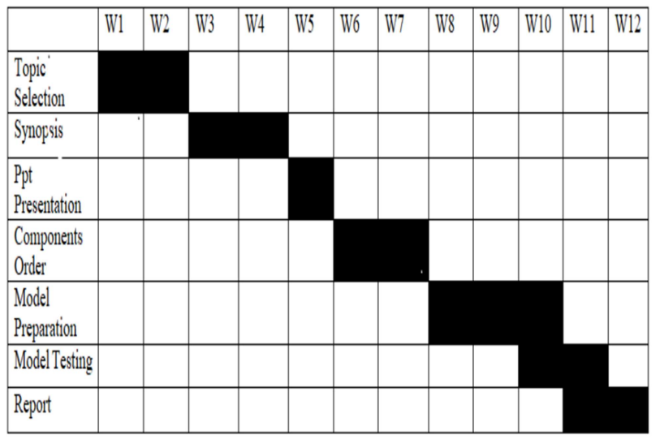

1. **References:**

**[1]** A. Ahuja and P. Khare, “Design a Robust Controller for BLDC Speed Control,” in IEEE 6th International Conference on Computing, Communication, Control and Automation (ICCUBEA-2022), Pune: IEEE Explorer, 2022, pp. 1–6. doi: 10.1109/ICCUBEA54992.2022.10011128

[2] Y. V. Hote, “Relative Stability Analysis of Perturbed Cart Inverted Pendulum: An Experimental Approach,” IETE Tech. Rev., vol. 35, no. 6, pp. 640–655, Sep. 2018. doi: 10.1080/02564602.2017.1370396.

[3] Y. V. Hote and S. Saxena, “Adaptive Policy for Load Frequency Control,” IEEE Trans. Power Syst., vol. 33, no. 1, pp. 1142–1144, 2018. doi: 10.1109/TPWRS.2017.2755468.